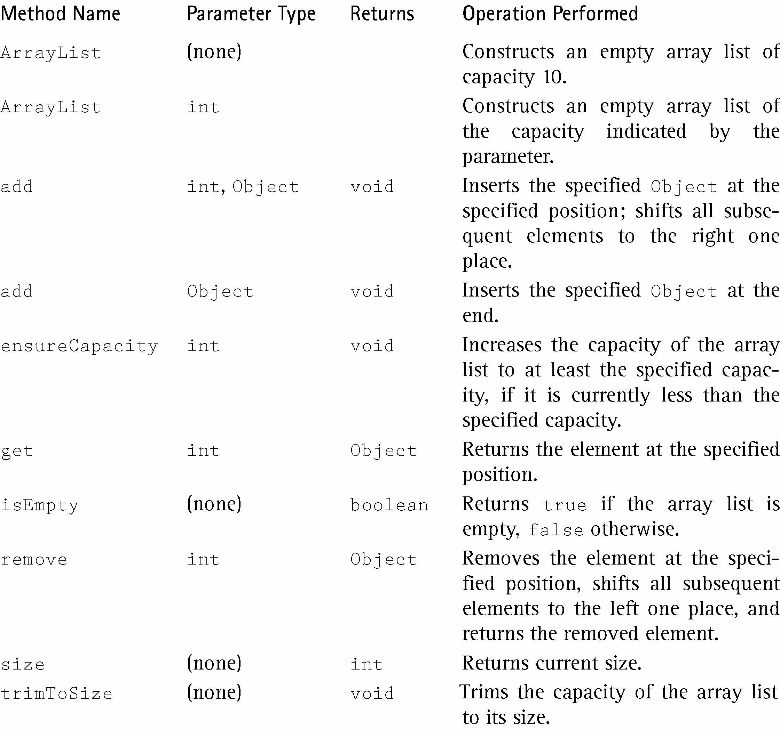

import java.util.*;
public class arrayList
{
public static void main(String[] args)
{
ArrayList<String> a = new ArrayList<String>(4);
a.add("NC");
a.add("SC");
a.add("GA");
a.add(2, "VA");
a.set(1, "TN");
a.remove(a.indexOf("VA"));
a.add("FL");
a.add(a.get(a.size()-1));

System.out.println(a.size());
for (int i = 0; i < a.size(); i++)
System.out.print(a.get(i) + " "); System.out.println();

Object[] myArray = a.toArray();
for (int i = 0; i < myArray.length; i++)
System.out.print(myArray[i]+ " ");
System.out.println();
}
}

Sample Run

5
NC TN GA FL FL
NC TN GA FL FL

